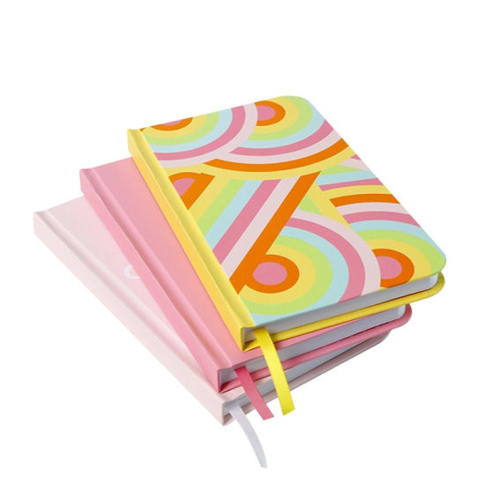

PRINTED JOURNALS

RYANA CALENDARS is selling wonderful PRINTED journals !at reasonable prices. It contains beautiful and designable covers!

RS 1050